Additional Assistance:
BusPurchases@des.wa.gov or
Nina Mesihovic
Enterprise Contracts & Procurement Specialist 3
Contracts and Procurement Division
Washington State Department of Enterprise Services
360-407-9404 |nina.mesihovic@des.wa.gov

Alec La Brayere (They/Them)
Enterprise Contracts & Procurement Specialist 2
Contracts and Procurement Division
Washington State Department of Enterprise Services
360-407-9366 | alec.labrayere@des.wa.gov

Bus Ordering Website:
https://apps.des.wa.gov/busordering/
Creating a login – Authentication

Requesting Access
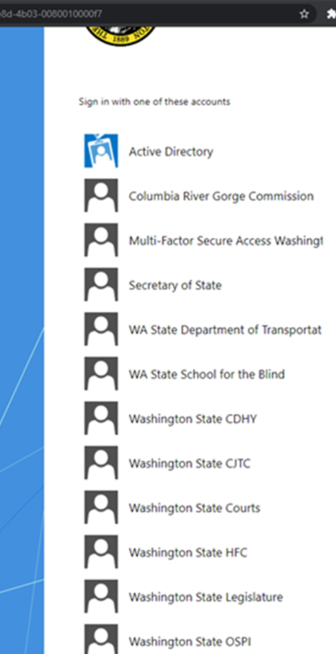
Select Multi-factor Secure Access Washington
You must create an account for Secure Access Washington at: https://secureaccess.wa.gov/myAccess/saw/select.do. Most transit agencies or out-of-state entities will need to create this account.
Click the Multi-factor icon to navigate to the website.
Do not create an account if you have an Active Directory (DES Employee) or if you have any of the other active listing’s agencies.
Return to the Bus Ordering website after you have created your account. Their website will not automatically navigate you back. https://apps.des.wa.gov/busordering/

Purchase Requests
Click “Start Your Order.”
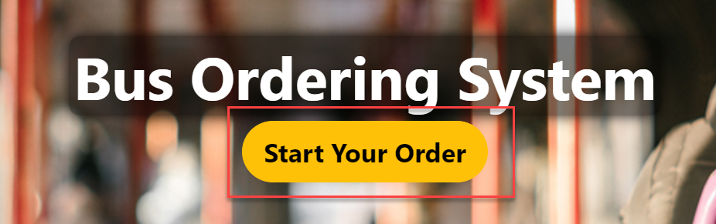

The Bus Purchase Request form is broken into different sections: 1) Request and Contract Information, 2) Vehicle Information, 3) Contact Information, 4) Delivery Information, 4) Additional Information and 5) Purchase Request Files.

Navigation on the Bus Purchasing Request screen

Cancel: Displays in the lower left-hand corner of the screen; cancels changes made in the form. Clicking this button will return you to the Purchaser Dashboard screen.
Save as Draft: Displays in the bottom middle right-hand corner of the screen; saves your Request without validating the information entered. Use this button if you need to save your place and return to the Request at a later time. Clicking this button will return you to the Purchaser Dashboard, where you will see your request with a status of Saved as Draft.
Submit: Displays in the lower right-hand corner of the screen; this button will validate the information and submit the request. If information has been entered incorrectly, or required fields are missing, you will receive an error notification that will direct you to correct the information.

Bus Purchasing Request – Request and Contract Information

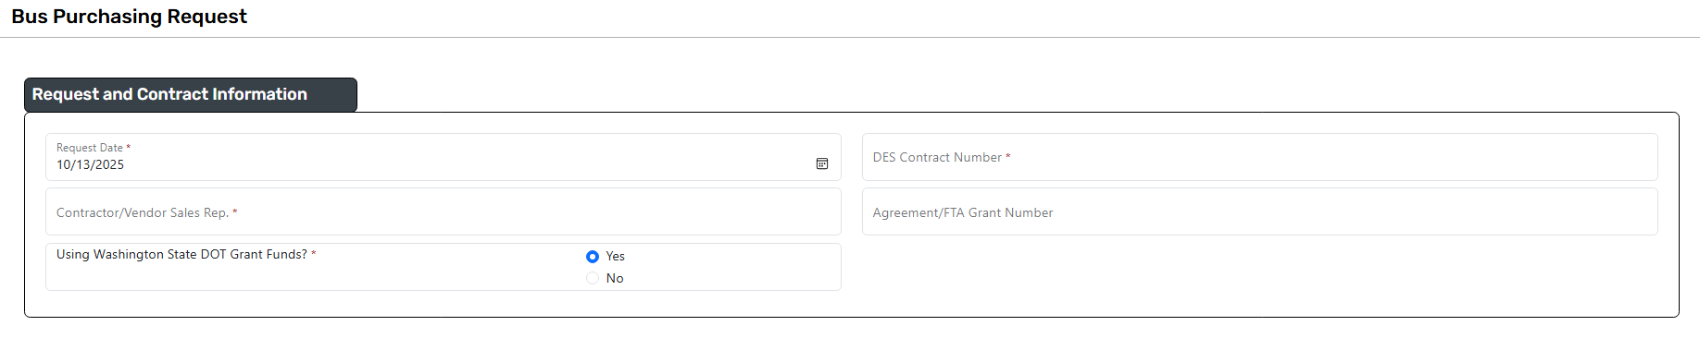
Request Date*: The date the request was created
DES Contract Number*: The Transit Bus Contract number
Contractor/Vendor Sales Rep*: The contractor/vendor sales rep you are purchasing from
Agreement/FTA Grant Number: The agreement or FTA Grant number being used, if applicable
Using Washington State DOT Grant Funds? *: If you’re using a grant from the Washington State DOT, select yes.

Bus Purchasing Request – Vehicle Information
Vehicle Type*:
Bus Length (feet)*:
Fuel Type*:
Quantity*:

Bus Purchasing Request – Contact Information
Contact Name*: The name of the person who will be contacted for any questions regarding the purchase request
Contact Phone Number*: The phone number of the Contact listed
Contact Email*: The email of the Contact listed

Bus Purchasing Request – Delivery Information
Address*: The address where the bus(es) will be delivered
City*: The city of the address where the bus(es) will be delivered
Select State*: The state of the address where the bus(es) will be delivered
Zip Code*: The zip code of the address where the bus(es) will be delivered

Bus Purchasing Request – Additional Information
Total Estimated Cost*:
Comments: Any comments you want to add in regard to the request. This will be visible to anyone with access to the purchase request.

Bus Purchasing Request – Purchase Request Files
Choose Files: Allows the user to browse to and select documents to add to the Bus Purchasing Request. At least one document is required to be added prior to submitting.
Clear File Selection: Allows the user to clear the selected files prior to submitting

Bus Purchasing Request - Returned for Information
Once you submit your Bus Purchasing Request for review, the request will be sent first to WSDOT for concurrence (if WSDOT grant funds are being used), and then to the Department of Enterprise Services Procurement Specialist for approval. When a Bus Purchasing Request is returned for information, you will receive an email notification.
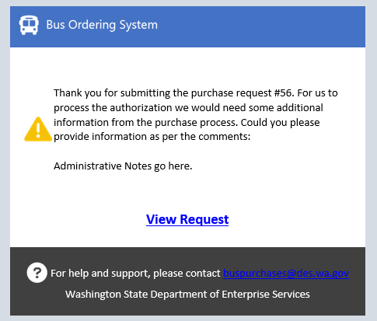

The status on the Purchaser Dashboard will be changed to Returned for Information and you will see an additional field
Administrator Notes: This is where you will see notes when a request is returned for information.
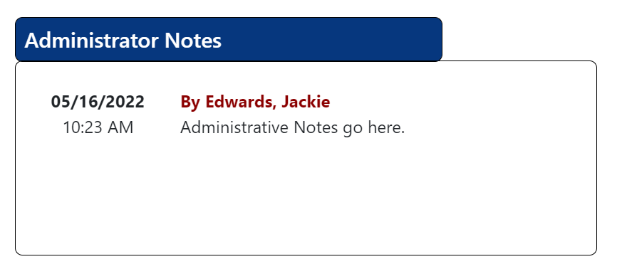

Bus Purchasing Request – Approved
When the Procurement Specialist approves your request, you will receive an email notification of the approval. If you are using WSDOT grant funds, this email also serves as WSDOT’s concurrence. Approval MUST be granted before orders are placed and prior to grants review/ invoices. DES will NOT backdate approval for completed purchasers.
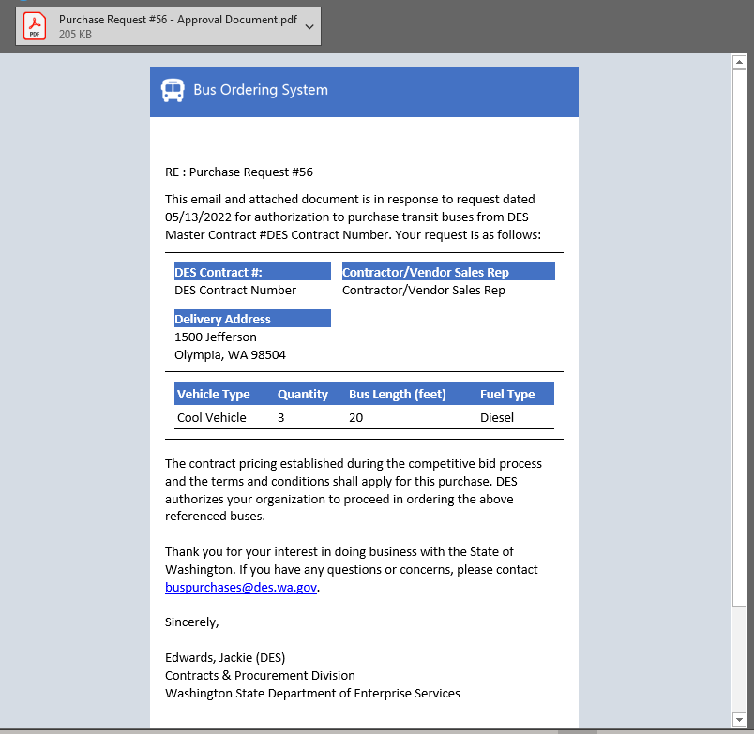
The status on the Purchaser Dashboard will be changed to Awaiting Purchase Order

Navigation on the Bus Purchasing Request –(Approved) screen

Cancel: Displays in the lower left-hand corner of the screen; cancels changes made in the form. Clicking this button will return you to the Purchaser Dashboard screen.
Submit: Displays in the lower right-hand corner of the screen; this button will validate the information and submit the request. If information has been entered incorrectly, or required fields are missing, you will receive an error notification that will direct you to correct the information.

You will see an additional Tab on the Bus Purchase Request

Purchase Information
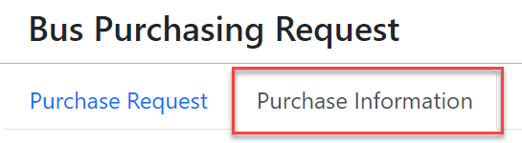
And additional sections on the Purchase Information Tab

Bus Purchasing Request – Vehicle Delivery Dates
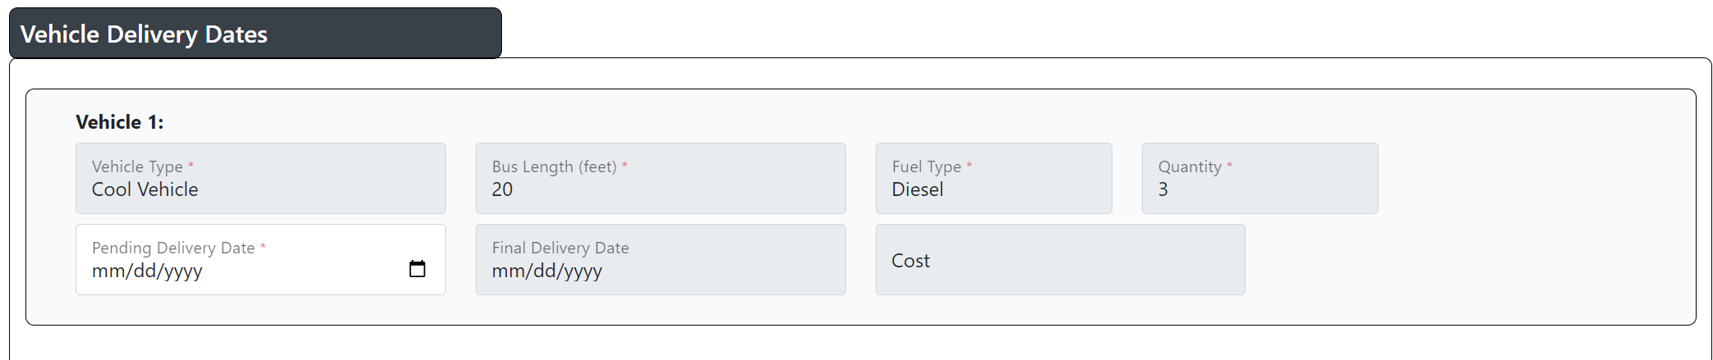
Vehicle Type*:Read only
Bus Length (feet)*: Read only
Fuel Type*: Read only
Quantity*: Read only
Pending Delivery Date*: The expected date of delivery for the bus(s) being ordered. Required prior to submitting
Final Delivery Date: Read only
Cost: Read only

Bus Purchasing Request-Purchase Order Files
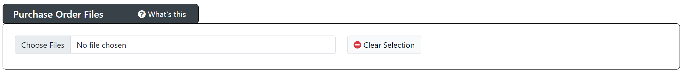
Choose Files: Allows the user to browse to and select documents to add to the Bus Purchasing Request. At least one document is required to be added prior to submitting.
Clear Selection: Allows the user to clear the selected files prior to submitting

After submitting the request the status will be changed to Pending Purchase Order Review while the Procurement Specialist reviews for approval

Bus Purchasing Request – Awaiting Final Delivery Dates
After the Purchase Order has been approved by the Procurement Specialist, the status will be changed to Awaiting Final Delivery Dates

You will see additional fields on the Bus Purchase Request-Purchase Information Tab:

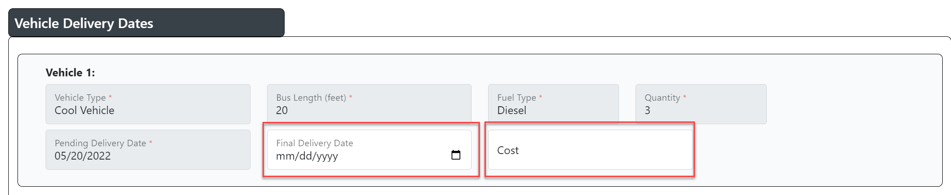
Final Delivery Date: The date that the final bus is delivered (if the quantity is more than 1 only add the date of the last vehicle that is delivered)
Cost: The total cost of a single vehicle that has been delivered

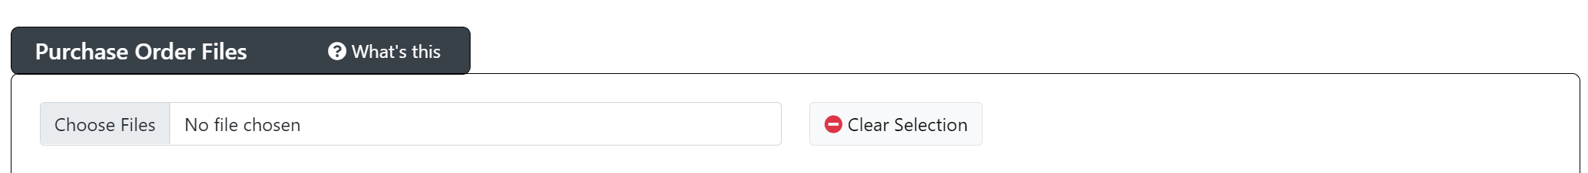

Choose Files: Allows the user to browse to and select documents to add to the Bus Purchasing Request. At least one document is required to be added prior to submitting.
Clear Selection: Allows the user to clear the selected files prior to submitting

